18.66: The volume of gas per molecule (see Problem 18.28) is 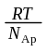, and the volume of a molecule is about 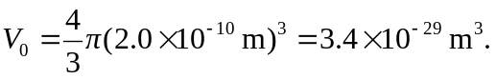 Denoting the ratio of these volumes as f,

“Noticeable deviations” is a subjective term, but f on the order of unity gives a pressure of 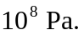Deviations from ideality are likely to be seen at values of f substantially lower than this.

